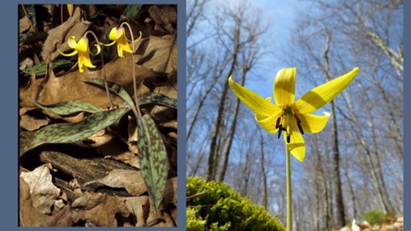

**Dyken Pond Environmental Education Center’s Response to Novel Corona Virus**

**Nature is resilient and we are too. We are here for you.**

**We can still connect with you!** Follow us on Facebook for Mystery Nature Photos on “What’s It Wednesdays? and Find out Fridays”. We’re also posting and sharing nature videos and some really great ideas on activities and resources for kids to keep them engaged in science and nature.

**We have instituted new guidelines for your next visit.** This is our effort to keep you, your loved ones and our staff safe. Public programs have resumed as of July 1 with new guidelines. Please check our website events for particulars. Nature can be a comforting resource right now.

The Center is open for you to visit, relax and enjoy the sights and sounds of nature. **A few reminders for your next visit:**

If you visit and find the parking lot full, please do not park on the grass. Consider going to a less crowded site. **Rensselaer County has many beautiful lands to enjoy.** See the links below.

**Enjoy the trails, but please keep a 6 foot distance between yourself and others.** Step off the trail to let others pass while maintaining social distancing. Do not return trail maps or self-guiding trail booklets. Both of these can also be downloaded from our website at: <http://www.dykenpond.org>

Keep dogs on a leash at all times.

Carry your own water. **Our water fountain is closed.**

**Composting bathroom is open**. Please remember that it is only as clean as the last person to use it. Bring your own sanitizer and/or wipes to clean door knobs.

Kayak access to the lake will begin May 1. After this date, the gate will be unlocked during daylight hours from 9am until 7pm. The gate is self-service. After unloading your gear at the lake, please be sure to close the gate behind you and park at the parking lot.

During your visit, you may contact staff at 518 658-2055, generally between 9am – 4pm.

Here are a few other areas in Rensselaer County to visit. Please go their websites for updated information before you visit.

Papscanee Nature Preserve: [Papscanee Island Nature Preserve](https://www.alltrails.com/trail/us/new-york/papscanee-island-nature-preserve-north-entrance)

Grafton Lakes State Park: [Grafton Lakes State Park](https://parks.ny.gov/parks/graftonlakes/details.aspx)

Schodack Island State Park: [Schodack Island Sate Park](https://parks.ny.gov/parks/schodackisland/maps.aspx)

Rensselaer Plateau Alliance: [Conservation Lands](https://www.rensselaerplateau.org/projects-c19ws)

Rensselaer Land Trust: [Public Preserves](https://www.renstrust.org/explore/preserves)

Taconic Hiking Club: [Taconic Crest Trail](https://taconichikingclub.org/)

Whether in your local park, backyard or at any of Rensselaer County's beautiful public lands, **we encourage time outside while maintaining distance from others using these spaces.**

In these uncertain times, let Nature be your guide. Every day, look for:

Five beautiful things

Four sounds

Three things to wonder about

Two things you’re curious about

If you have any questions or concerns, please give me a call or email.

Be well,



Lisa Hoyt

Director

518 658-2055

e-mail: dykenpond@gmail.com